STAT 345: Monopoly Rules

1. Rules of Monopoly:
   1. **Object**: Become the wealthiest player through buying, renting, and selling property.
   2. **Set-up**:
      1. Equipment: Board, 2 dice, tokens, 32 houses, 12 hotel, Chance cards, Community Chest cards, a Title Deed card (one for each property) and play money.
      2. Preparation:
         1. Each player should choose a token to represent their person as they move around the board.
         2. Each player is given 1500 monopoly dollars as follows: 500 (x2), 100 (x2), 50 (x2), 20 (x6), 10 (x5), 5 (x5), 1 (x5)
         3. All other money and equipment go back to bank
      3. The Bank: (I think the banker can be autonomous)
         1. Holds money in bank and Title Deeds, hotels, and houses prior to purchase by players.
         2. Pays salaries and bonuses (Pass Go and Chance/Community?)
         3. Loans money when required on mortgages.
         4. Collects all taxes, fines, loans and interest, and the price of all the properties which it sells and auctions.
         5. The Bank has “unlimited funds.”
   3. **The Play:**
      1. General Play:
         1. The player with the highest dice total begins the game[1] (if Banker is a player, they roll first)
         2. Begin at GO, roll dice and move the token in the “direction marked by the arrow” the number of spaces indicated by the dice.
         3. After Player 1’s turn has been completed, the turn passes to the player on Player 1’s left. The tokens remain on the spaces occupied and proceed from that point on the player’s next turn.
         4. Two or more tokens may rest on a single space.
      2. GO: Each time a player’s token lands on or passes GO, the Banker (Bank) will pay that player a M$ 200 salary.
      3. Property Rules:
         1. Buying: Whenever a player lands on an unowned property, the player may decide whether or not to purchase the property from the Bank at its listed price.
            1. If the player decides to purchase the property, the player will receive the Title Deed card as proof of ownership. (This should be placed in such a way as to be (reasonably) visible to all players)
            2. If the player does not wish to purchase the property, the Banker (Bank) will sell it at auction to the highest bidder.[2] (Note: Any player, including the one who decided not to purchase the property at its listed price, may bid.)
         2. Paying Rent: When a player lands on a property which is not owned by them, the owner may collect rent from you in accordance with the list printed on the its Title Deed. Additional Conditions:
            1. If the property owned by the other player is currently mortgaged, no rent may be collected.
            2. If all properties of the same color group are owned by the same player, the owner of said properties may charge double rent. (This rule applies to unmortgaged properties even if another property in that color-group is mortgaged.)
            3. Houses and hotels increase the value of the property (?as determined by the Title Deed)
            4. The owner may not collect the rent if they fail to ask for it before the next player throws the dice.
      4. Specialty Spaces and Actions:
         1. Chance and Community Chest:
            1. When you land on either of these spaces, take the top card from the deck indicated, follow the instructions, and return the card face down to the bottom of the deck.
            2. The one exception to the rule is that the “Get out of Jail Free” Card is held by the player until used or sold to another player at an agreed upon price.
         2. Income Tax:
            1. You may estimate your tax at M$ 200 or pay 10% of your total worth to the Bank, which is the sum of all your cash on hand, printed prices of mortgaged and unmortgaged properties and cost price of all buildings you own. *You must decide which option you will take before you add up your total worth.
         3. Jail:
            1. A player is sent to jail if any one of the three occur:

Your token lands on the “Go to Jail” space

You draw a card marked “Go to Jail”

You roll doubles three times consecutively

* + - * 1. When you are sent to Jail you cannot collect your M$ 200 salary in that move since, regardless of where your token is on the board, you must move it directly into Jail. Yours turn ends when you are sent to Jail.
        2. A player gets out of jail by one of four methods:

Rolling doubles on any of your next three turns

Using a “Get out of Jail Free” card

Purchasing a “Get out of Jail Free” card from another player

Paying a fine of M$ 50 before you roll the dice on either of your next two turns

* + - * 1. If you do not throw doubles by your third turn, you must pay the $50 fine. You then get out of Jail and immediately move forward the number of spaces shown by your throw.
        2. Even though you are in Jail, you may buy and sell property, buy and sell houses and hotels and collect rents.
      1. Free-Parking:
         1. A player landing on this place does not receive any money, property, or reward of any kind. This is just a “free” resting place.
    1. Houses, Hotels, and Building Shortages:
       1. Houses:
          1. When you own all the properties in a color-group you may buy houses from the Bank and erect them on those properties.
          2. If you buy one house, you may put it on any one of those properties. The next house you buy must be erected on one of the unimproved properties of this or any other complete color-group you may own.
          3. The price you must pay the Bank for each house is shown on your Title Deed card for the property on which you erect the house. The owner still collects double rent from an opponent who lands on the unimproved properties of his/her complete color-group.
          4. Following the above rules, you may buy and erect at any time as many houses as your judgement and financial standing will allow. But you must build evenly, i.e., you cannot erect more than one house on any one property of any color-group until you have built one house on every property of that group. You may then begin on the second row of houses, and so on, up to a limit of four houses to a property. As you build evenly, you must also break down evenly if you sell houses back to the Bank.
       2. Hotels:
          1. When a player has four houses on each property of a complete color-group, he/she may buy a hotel from the Bank and erect it on any property of the color-group. He/she returns the four houses from that property to the Bank and pays the price for the hotel as shown on the Title Deed card. Only one hotel may be erected on any one property.
       3. Building Shortages:
          1. When the Bank has no houses to sell, players wishing to build must wait for some player to return or sell his/her houses to the Bank before building. If there are a limited number of houses and hotels available and two or more players wish to buy more than the Bank has, the houses or hotels must be sold at auction to the highest bidder.
    2. Other Property Related Rules:
       1. Selling Property:
          1. Unimproved properties, railroads and utilities may be sold to any player as a private transaction for an agreed upon amount; however, no property can be sold to another player if buildings are standing on any properties of that color-group. Any buildings so located must be sold back to the Bank before the owner can sell any property of that color-group. Houses and hotels may be sold back to the Bank at any time for one-half the price paid for them
          2. All houses must be sold back to the Bank one by one, evenly. (Hotels = 5 houses)
       2. Mortgages:
          1. Unimproved properties can be mortgaged through the Bank at any time. Before an improved property can be mortgaged, all the buildings on all the properties of its color-group must be sold back to the Bank at half price.
          2. No rent can be collected on mortgaged properties or utilities, but rent can be collected on unmortgaged properties in the same group.
          3. In order to lift the mortgage, the owner must pay the Bank the amount of the mortgage plus 10% interest. When all the properties of a color-group are no longer mortgaged, the owner may begin to buy back houses at full price.
          4. However, the owner may sell this mortgaged property to another player at any agreed price. If you are the new owner, you may lift the mortgage at once if you wish by paying off the mortgage plus 10% interest to the Bank. If the mortgage is not lifted at once, you must pay the Bank 10% interest when you buy the property and if you lift the mortgage later you must pay the Bank an *additional* 10% interest as well as the amount of the mortgage.
       3. Bankruptcy:
          1. You are declared bankrupt if you owe more than you can pay either to another player or to the Bank. (It sounds like this is strictly monetary; not sure if a player could choose to mortgage their properties before to try to stay in the game.)

If your debt is to another player, you must turn over to that player all that you have of value and retire from the game. In making this settlement, if you own houses or hotels, you must return these to the Bank in exchange for money to the extent of one-half the amount paid for them; this cash is given to the creditor. If you have mortgaged property you also turn this property over to your creditor but the new owner must at once pay the Bank the amount of interest on the loan, which is 10% of the value of the property. The new owner who does this may then, at his/her option, pay the principal or hold the property until some later turn, then lift the mortgage. If he/she holds property in this way until a later turn, he/she must pay the interest again upon lifting the mortgage.

Should you owe the Bank, instead of another player, more than you can pay (because of taxes or penalties) even by selling off buildings and mortgaging property, you must turn over all assets to the Bank. In this case, the Bank immediately sells by auction all property so taken, except buildings. A bankrupt player must immediately retire from the game. The last player left in the game wins.

* 1. **Short Game Rules Omitted**

**Community Chest and Chance:**

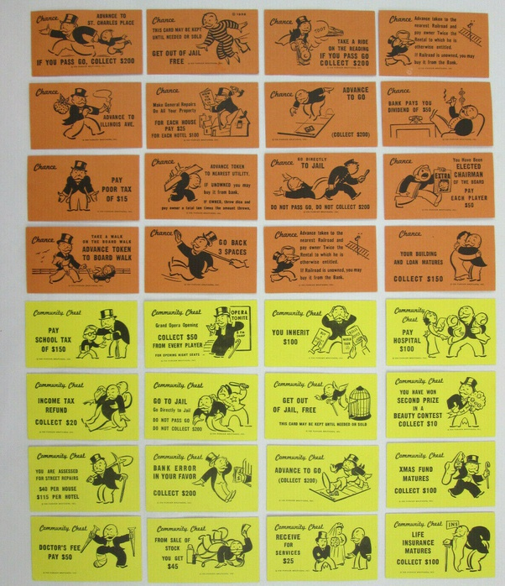

1. It would be an interesting statistic to note: “Does order of play influence outcome?” (E.g., Does Player 1 win more often than Player 2-4?)
2. The bidding should be factored into our cost-benefit analysis of a property. (At which price is a property a good buy?)